### **1 Assignment: AI Workflow Analysis and Summary Using Video Insights Plugin**

#### Objective:

The objective of this assignment is to use the Video Insights plugin to analyze and summarize video content on advanced AI workflows, focusing on the potential implications and advancements in software architecture. Participants will apply the insights gained to improve their understanding of AI agentic workflows and consider how these can be integrated into software development processes.

#### Assignment Details:

* Video Summary:
  + Link: [Andrew Ng STUNNING AI Architecture Revealed](https://www.youtube.com/watch?v=wM5837pVh1g)
  + Use the Video Insights plugin to generate a comprehensive summary of the video. Focus on key points Andrew Ng makes about AI agentic workflows, their advantages, and potential applications.
  + Pay particular attention to the iterative processes discussed, how they compare with traditional workflows, and the implications for software development.
* Practical Application:
  + Reflect on how the concepts discussed in the video can be applied in your current projects or in the design of new software architectures.
  + Consider the benefits and challenges of integrating AI agentic workflows into your software development lifecycle.
* Explore Further:
  + Choose another video related to AI, machine learning, or software architecture advancements. Here are a few suggestions:
    - [AI in Real-Time Systems](https://www.youtube.com/link-to-specific-video)
    - [Machine Learning Deployment Strategies](https://www.youtube.com/link-to-specific-video)
  + Use the Video Insights plugin to generate a summary of the selected video.
  + Compare and contrast the insights from this video with those from Andrew Ng's presentation.

#### Deliverables:

* A detailed report including:
  + Summaries of both videos.
  + A discussion on the application of AI agentic workflows in software architecture.
  + Comparisons of key themes between the two videos.
* A short presentation (10-15 slides) summarizing your findings and recommendations for incorporating AI workflows into software development practices.

#### Submission Instructions:

* Submit your report and presentation slides as PDF files via the course submission portal.
* Ensure that your work is well-organized and clearly communicates your analysis and conclusions.

This assignment aims to deepen your understanding of AI's evolving role in software architecture and to enhance your analytical skills using advanced tools like the Video Insights plugin.

====

Video Summarizing

<https://www.youtube.com/watch?v=wM5837pVh1g>

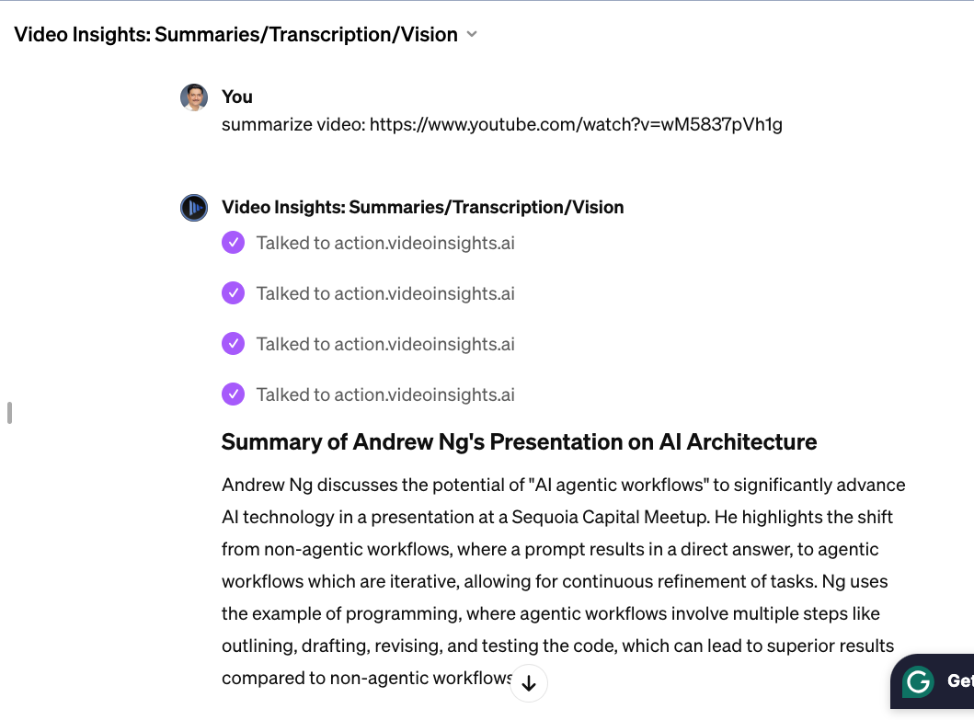

## Assignment 2:

summarize: https://arxiv.org/pdf/2401.06795.pdf



Video Insights: Summaries/Transcription/Vision

The paper titled "AI and Generative AI for Research Discovery and Summarization" explores the capabilities and limitations of large language models (LLMs) like ChatGPT in enhancing research discovery and summarization tasks. The paper identifies that while LLMs can provide quick and comprehensive summaries and assist in literature discovery, they sometimes produce inaccuracies or "hallucinations" in their outputs, especially when used as standalone search tools for academic content. This underscores the need for careful verification and a hybrid approach that combines LLM outputs with human oversight and advanced algorithms to ensure factual accuracy and reliability​ ([ar5iv](https://ar5iv.org/pdf/2401.06795.pdf))​.

A significant focus of the paper is on abductive reasoning, a process where the most plausible explanation for a set of observations is inferred. LLMs, such as GPT-4, have shown promise in mimicking this type of reasoning, which is crucial in research discovery. For instance, LLMs can help identify existing methods or algorithms based on descriptions provided by researchers, which may not have conventional names or be straightforward to discover through traditional search methods​ ([ar5iv](https://ar5iv.org/pdf/2401.06795.pdf))​.

The paper also discusses the impact of generative AI on literature discovery and comparison, highlighting how web-based tools like Semantic Scholar and Consensus have begun to integrate AI features to enhance their search capabilities. These tools use AI to interpret research prompts and provide relevant search results, often supplemented with brief summaries created using generative models. This integration aims to improve the relevance and precision of literature searches in scientific and academic research​ ([ar5iv](https://ar5iv.org/pdf/2401.06795.pdf))​.

Overall, the study emphasizes the transformative potential of AI in research and academic settings, while also calling attention to the importance of augmenting AI tools with robust verification mechanisms to harness their full potential responsibly. For a detailed exploration of these themes, you can view the full paper [here](https://ar5iv.labs.arxiv.org/html/2401.06795).

## Assignment 3

Summarize this article: https://www.theguardian.com/technology/2024/apr/10/ai-race-heats-up-as-openai-google-and-mistral-release-new-models



Video Insights: Summaries/Transcription/Vision

The AI industry is experiencing a notable surge in activity as major players like OpenAI, Google, and the French startup Mistral release new AI models almost simultaneously. This flurry of releases is setting the stage for a competitive summer, with each company showcasing advancements in their technology.

OpenAI unveiled the final version of GPT-4 Turbo, a multimodal system that can process text and images, indicating a significant step forward in AI capabilities. Google, not to be outdone, released Gemini Pro 1.5, which expands upon multimodal capabilities by including audio and video inputs, pushing the boundaries of what AI systems can interpret and process.

Mistral introduced its model, Mixtral 8x22B, which stands out for being open source, allowing developers and researchers to download and build upon the model without restrictions. This approach, while fostering innovation and broader access to advanced technology, has raised concerns about the potential misuse of AI technology due to the lack of control once the models are released into the public domain.

These developments suggest a trend towards more sophisticated, multimodal AI systems that could integrate more seamlessly into various digital platforms and applications, enhancing user interaction beyond traditional text-based interfaces. However, there are ongoing debates about the implications of rapidly advancing AI technology, including ethical considerations and the potential for unintended consequences​ ([AbiEdu](https://abiedu.com/ai-race-heats-up-as-openai-google-and-mistral-release-new-models-artificial-intelligence-ai/))​​ ([Geo](https://www.geo.tv/latest/538767-ai-arms-race-heats-up-openai-google-and-mistral-release-cutting-edge-models-in-rapid-succession) )​​ ([Yahoo News - Latest News & Headlines](https://news.yahoo.com/google-takes-openai-release-gemini-150213012.html))​.

For more detailed information, you can read the full articles on AbiEdu, Geo TV, and Yahoo News.